INFLUENCE OF GROUND MOTION MODEL SELECTION ON SEISMIC HAZARD FOR JOHANNESBURG

Abstract
Selecting ground motion prediction models (GMMs) is crucial in assessing seismic hazard levels in a specific region. This study investigates the influence of GMM selection on seismic hazard assessment in Johannesburg, South Africa. Most seismic events affecting Johannesburg are related to mining activities and water ingress into the underground mine voids. The most seismically active regions in South Africa include areas around Klerksdorp, Welkom, and Carletonville. These regions experience a significant number of earthquakes, with mining activities being a major factor contributing to seismic events. Ten ground motion prediction equations were selected from regions of similar tectonics setting and were assessed to see if they fit the available local data. Six of these were also compared to the ground motions produced by the 14 August 2014 earthquake, which occurred in the Orkney area, one of the mining areas in South Africa. Sensitivity analysis were also carried out to assess the influence of Ground-motion prediction equations (GMPEs) on the seismic hazard of Johannesburg. The results indicate that the choice of GMM significantly affects the estimation of seismic hazard levels in Johannesburg. Different GMMs can lead to varying ground shaking intensity predictions, impacting risk assessments and engineering design considerations. The findings highlight the importance of carefully selecting appropriate GMMs tailored to Johannesburg’s specific geological and tectonic characteristics. Understanding how different models perform in this region is essential for accurate seismic risk mitigation strategies.

Key words: Seismic hazard assessment, Ground motion prediction equations, Sensitivity analysis, Johannesburg

Introduction
The ground motion model predicts the distribution of expected ground-motions conditional on the occurrence of a given earthquake scenario. Selecting an appropriate ground motion model is a critical aspect of seismic hazard analysis (SHA). Ground-motion prediction equations (GMPEs) establish a relationship between a ground-motion parameter (such as peak ground acceleration (PGA), peak ground velocity (PGV), peak spectral acceleration (PSA)) and a series of explanatory variables that describe the earthquake source, wave propagation path, and local soil conditions (Douglas, 2003; Stewart et al., 2015; Akkar et al., 2014). The importance of PGA and various PSAs lies in their significance as critical parameters for assessing seismic risk and designing earthquake-resistant structures. PGA measures the maximum acceleration of ground motion during an earthquake, while PSAs indicate the maximum acceleration at specific frequencies. These parameters are essential for evaluating how structures respond to seismic events, as different structures have distinct natural frequencies. Every SHA analysis must include a GMPE that accurately models the transmission of ground motion from the earthquake source to the site.
Ideally, it is preferable to use a GMPE derived from local data, but this is only possible in regions of dense station coverage and high seismicity, such as Japan or California (Douglas et al., 2011; Bommer et al., 2015a). In South Africa, the only accelerometric stations installed are in the cluster networks in the mining regions. These stations have been in operation since 2012, and the existing ground motion record dataset does not allow users to derive such a model due to the lack of strong motion earthquakes (Grobbelaar et al., 2017). Although several moderate seismic events (e.g., the December 1976 M5.2 Welkom event, the April 1977 M5.2 Klerksdorp, and the 2005 M5.3 Stilfontein) have been recorded in South Africa, these were not captured by the accelerometers for them to be used in developing GMPEs (Fernandez and Van der Heever, 1985; Durrheim et al., 2006). Although the 1976 event was recorded on accelerometers, we only had access to the recorded data apart from - that quoted in Fernandez and Van der Heever (1985). In this regard, models from other regions are carefully selected and tested to determine if they fit appropriately with the local data. In actual use in hazard analysis, a ground motion model will be called upon to predict accelerations from the complete range of magnitude and distance scenarios (Shoja-Taheri et al., 2010; Stewart et al., 2015; Midzi et al., 2020). A model that is derived from a dataset that only covers part of this range may not be reliable. This is mainly a problem because the datasets frequently tend to be biased towards small earthquakes at short distances and large earthquakes at long distances (Musson and Sargeant, 2007). This can result in scaling issues when ground motions need to be calculated for parts of the dataset's magnitude-distance domain that require more accurate representation. Otherwise, one must adopt either a relationship in which local data is augmented with data from a broader region or a relationship from anywhere in the world that is considered to be tectonically similar (Cotton et al., 2006; Bommer et al., 2015a; Midzi et al., 2020).
The procedure for selecting the appropriate GMPEs for use in the seismic hazard assessment has been well-documented by several authors (Cotton et al., 2006; Scherbaum et al., 2009; Bommer et al., 2010). This process should result in the miniature set of independent models that capture the expected range of possible ground motions in the target region (Cotton et al., 2006). This most miniature set of GMPEs will be compared with local data to verify if they capture the local data’s uncertainty. Many studies have been devoted in recent years to evaluating the performance and reliability of the GMPEs (Cotton et al., 2006; 2008; Shoja-Taheri et al., 2010; Bommer et al., 2003; 2011). Among them, Cotton et al. (2008) investigated the consequences of using them outside their range of validity. It is often the case of predicting of spectral ordinates from earthquakes of small-to-moderate magnitude, for which the observed spectral values are systematically smaller. The problem arises because of the scarcity of strong motion data needed to definitively resolve the shape of the attenuation curve. The uncertainty in the selection process is represented in the branches of the logic tree and weighted according to the analyst’s relative confidence (Bommer et al., 2005) or degree of belief using available information.

Identification and testing of suitable ground motion prediction equations for Johannesburg
Given its position relative to plate boundaries, relatively low earthquake activity and, the slow rate of crustal deformation, South Africa is generally considered a Stable Continental Region (SCR). According to Malservisi et al. (2013) and Stamps et al. (2018), South Africa’s deformation rates are less than 1mm yearly. Therefore, an analogy for this region would be a SCR such as Eastern North America (ENA) and Australia, for which a several ground-motion models are available. Unlike ENA, however, the current tectonic regime of the southern African region (mainly along the eastern parts) shows evidence of extensional tectonic stresses with dominant normal faulting (Hartnady, 2002; Stamps et al., 2018; Manzunzu et al., 2019; Midzi et al., 2020). Studies by Johnston et al. (1994) show that extensional tectonic stresses are uncommon within SCRs, so alternative GMPEs from active shallow crust can be selected. Ninety percent of seismicity in South Africa comes from the mining regions, thus motivating for us to identify and select suitable GMPEs, preferably derived from induced seismicity. Ground motions from induced seismicity are characterised by high frequencies which tend to attenuate faster than natural tectonic events (McGarr and Fletcher, 2005; Manzunzu et al., 2017; Zulu, 2018).
Ten pre-selected GMPEs from the three tectonic regions mentioned above (SCR, shallow active crusts (SAC), induced seismicity regions (ISR)) were tested on how well they predict ground motion in South Africa using local data for different spectral periods. The information for each GMPE is shown in Table I below. The method of Scherbaum et al. (2004) was applied in order to rank these 10 GMPEs. This method is based on a transparent and data-driven process that quantifies the model fit and measures how well the underlying model assumptions are met. Several GMPEs in literature were derived from induced seismic events. However, only one (the relation by McGarr and Fletcher, 2005) is derived explicitly from mining-related events. Most of the other GMPEs were derived geothermal or fracking events. However, the McGarr and Fletcher (2005) relation has been observed to grossly under predict ground motion for events of M_{W} > 5.0 and distances larger than 10 km (Zulu, 2018). Most GMPEs derived from induced seismicity were derived for only one spectral period, i.e., peak ground acceleration (PGA). At the same time, in this study, we needed GMPEs that catered for other spectral periods. Hence, they were not tested in this study. The only GMPE from induced seismicity applied in this study was developed by Atkinson (2015) for geothermal sources for spectral periods up to 2 seconds.
Table I: GMPEs pre-selected from different tectonic settings to be used in this study, including the regions (SCR, SAC and ISR) for which they were developed.
 | GMPE | Tectonic region | Magnitude range (M_{W}) | Distance range (km)
1 | Boore and Atkinson (2008) as modified by Atkinson and Boore (2011) | Referenced empirical model for eastern North America (SAC) | 5 - 8 | 0 - 400
2 | Atkinson and Boore (2006) as modified by Atkinson and Boore (2011) | Extended stochastic model for eastern America (SCR) | 3.5-8 | 1-1000
3 | Campbell (2003) | Hybrid model for eastern North America (SCR) | 5-8.2 | 1-1000
4 | Rietbrock et al., (2013) | Stochastic model for United Kingdom (SCR) | 4.5 – 7.5 | 1 - 1000
5 | Frankel et al. (1996) as parameterized by EPRI (2004) | Stochastic model for eastern North America | 5 - 8 | 1 - 300
6 | Akkar et al., (2014) | Europe and Middle East (SAC) | 4-8 | 1 - 300
7 | Silva et al. (2002) | Stochastic model for eastern North America (SCR) | 4.5 – 8.5 | 1 - 400
8 | Pezeshk et al. (2011) | Hybrid model for eastern North America (SCR) | 5-8 | 1-1000
9 | Toro et al. (1997) modified by Toro (2002) | Stochastic model for eastern North America (SCR) | 5 - 8 | 1 - 100
10 | Atkinson (2015) | Small to medium events at short distance (ISR) | - - 6 | 5 - 40

A database of 61 seismic events (Figure 1) was compiled from the South African mining Cluster Networks for use in the testing of the GMPEs. Our dataset is mainly composed of mining-related events. However, according to Douglas et al. (2013) and Atkinson (2015), ground motion from natural and induced sources are indistinguishable. Therefore, we also included GMPEs derived from natural earthquake sources in this study.
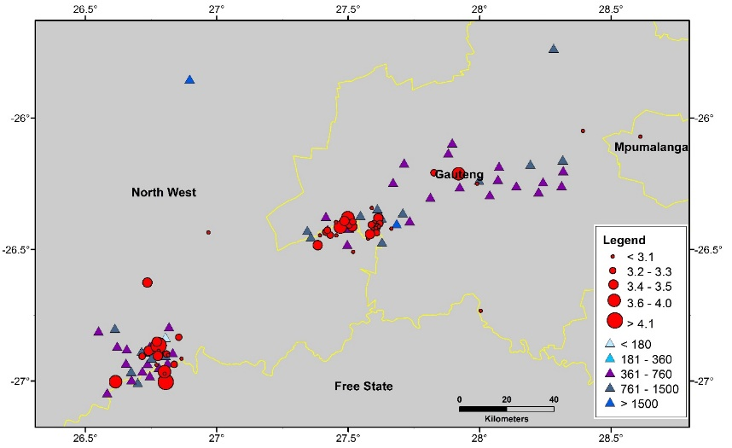
Figure 1: Location of earthquakes used in the testing of GMPEs. The figure shows the spatial distribution of the seismic events and the stations. Triangles represent the stations recording the events with each station having a V_{s30} value indicated with the colour; circles are the seismic events.

Only events with good waveform data regarding signal-to-noise ratio and recorded by at least five stations were included. These contributed 2 018 two-component horizontal acceleration time series within a hypocentral distance range of 0.8 km to 350 km. The magnitude of the events ranged from 3.0 to 5.5. The various magnitude ranges of the events and the number of records associated with each listed magnitude value are presented in Table II. Hypocentral distance was taken as the distance metric for all comparisons in place of rupture distance. Due to the moderate magnitudes of all earthquakes and shallow depth, the assumption of equality between hypocentral and rupture distance is inferred (Gupta, 2006).
Table II: Number of events and recordings in different magnitude range showing the distance range of the recording stations.
Magnitude | 3.0 | 3.1 | 3.2 | 3.3 | 3.4 | 3.5 | 3.6 | 3.9 | 4.6 | 5.5
No. of events | 11 | 13 | 11 | 7 | 3 | 6 | 3 | 1 | 1 | 1
No. of recordings | 284 | 424 | 405 | 265 | 130 | 220 | 137 | 41 | 40 | 38
Hypocentral Distance (km) | 1.4 - 349 | 2.1 - 284 | 0.9 - 232 | 1.8 - 337 | 0.9 - 218 | 1.2 - 231 | 2.4 - 218 | 4.3 - 117 | 4.2 - 195 | 4.8 - 177

No field investigations were carried out to determine the site conditions at all the seismic stations. Instead, we estimated values based on the surface geology where the stations are located. Given the need for more detailed geological information at all the seismic stations, five site classes based on the National Earthquake Hazards Reduction Program (NEHRP) (FEMA, 2003) site classification were used. The NEHRP site classification forms one of the standard site classifications used in GMPEs (Table III). The NEHRP site classes are used to categorize sites based on their seismic amplification potential. V_{s}30, representing the average shear-wave velocity to a depth of 30 meters, is a crucial parameter in determining these classes. The Vs30 values indicate how the ground will respond to seismic waves, with lower V_{s}30 values typically associated with higher shaking amplification during earthquakes.
Table III: NEHRP site classification scheme (FEMA, 2003). V_{S30} is the shear-wave velocity averaged over the uppermost 30m.
Site Class | Geologic Description | V_{S30} (m/s)
A | Hard Rock | V_{S30} > 1500
B | Soft Rock | 760< V_{S30} ≤1500
C | Stiff soil | 360< V_{S30} ≤760
D | Soft soil | 180< V_{S30} ≤360
E | Very soft soil | V_{S30} ≤180

Most of the stations are located on soft rock (Site Class B), followed by stiff rock (site class C). This is illustrated clearly in Figure 2, which shows the distribution of earthquake magnitude with hypocentral distance, where each record is linked to the appropriate site conditions.

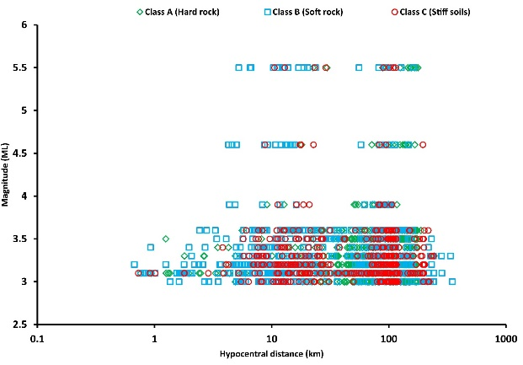
Figure 2: Illustration of site classification of the seismic station records representing different site classes based on NEHRP site classification.

The comparison of observed and calculated ground motion is carried out by calculating residuals. Residuals are generally defined as the difference between the natural logarithm of the observed parameter (Y_{ij}) and the mean calculated parameters (Ŷ) for a given GMPE (equation 1; Shoja-Taheri et al., 2010; Skarlatoudis, 2017). For each observed waveform, the ground motion parameters are extracted at different spectral periods. Each ground motion parameter is compared with predicted ground motion by each individual GMPE at different spectral periods to compute the required residuals.
$r_{ij}={lnY}_{ij}-\ln{Ŷ}$ [1]

where lnY_{ij} is the value of the j^{th} record of the i^{th} event and lnŶ is the mean value of lnY computed using a particular GMPE. The results of the comparison were presented by considering intra-event and inter-event residuals, which are all usually close to zero and represent the residuals related to each individual source and to combined sources respectively. The intra-event terms presented here were obtained using the whole database of events for all available hypocentral distances in a similar way as reported by Graves et al. (2008). The two residuals are given by the following equations, 2 and 3.
$r_{ij}^{intra}=r_{ij}- η_{i}$ [2]

$r_{i}^{inter}=η_{i}- \frac{1}{N_{e}}\sum_{i=1}^{N_{i}}{η_{i}}$ [3]

where N_{e} is the total number of events. The mean of the residuals for the i^{th} event with N_{i} records is defined as in equation 4:
[4]
For each GMPE, the residuals were calculated for 5% damped pseudo spectral acceleration for periods 0.0s (PGA), 0.1s and 2.0s. In the following section, the results are presented by considering the figures related to the residuals (equation 2 and 3). Figure 3, Figure 4 and Figure 5 shows inter-event residuals for the pre-selected GMPEs (Table 1) and tested with observed data in this investigation for the three spectral periods (PGA, PSA = 0.15s and PSA = 2.0s).
The inter-event terms show similar variation with distance for most of the equations. For most GMPEs, the residuals are negative, with the lowest at about -0.01 and smaller at long periods, where residuals are less than -0.005 (and 0.005 where positive) for periods greater than 1.0 seconds. The inter-event residual distribution implies that most of the models (in particular, Rietbrock et al. (2013); Campbell (2003), Atkinson (2015), and Toro (2002)) overestimate the observed ground motion. The residuals for PGA are large for Silva et al. (2003), Pezeshk et al. (2011), Frankel et al. (1994), and Atkinson and Boore (2006) GMPEs (Figure 3). For spectral period T = 0.15s, Atkinson (2015), Akkar et al. (2014), Campbell (2003), Rietbrock et al. (2013 and Pezeshk et al. (2011) GMPEs have negative residual values, while Boore and Atkinson (2008) and Atkinson and Boore (2006) have positive values (Figure 4). All GMPEs slightly overestimates with distribution very close to the zero-residual line (Figure 5).
Analysis of intra-event residuals shows larger residuals (between -0.2 to 0.2) compared to inter-event residuals (Figure 6, Figure 7 and Figure 8). High scattering at low magnitudes is consistently observed for all the spectral periods. The scattering improves at high magnitudes but changes from positive to negative residuals with increasing periods. Large residual values seen in Figure 6 and Figure 7 might be due to the use of GMPEs outside their range of applicability. Silva et al. (2003), Rietbrock et al. (2013), Frankel et al. (1994), and Atkinson (2015) have large scatter for PGA compared to other GMPEs. The scatter is more significant for small-magnitude events than for moderate ones. For the spectral period T= 0.15s, all the GMPEs had residuals of less than 0.1, although they seemed to follow the trend of PGA. At spectral period 2.0s, the residuals are lower than ± 0.05, although they seem - more negative.

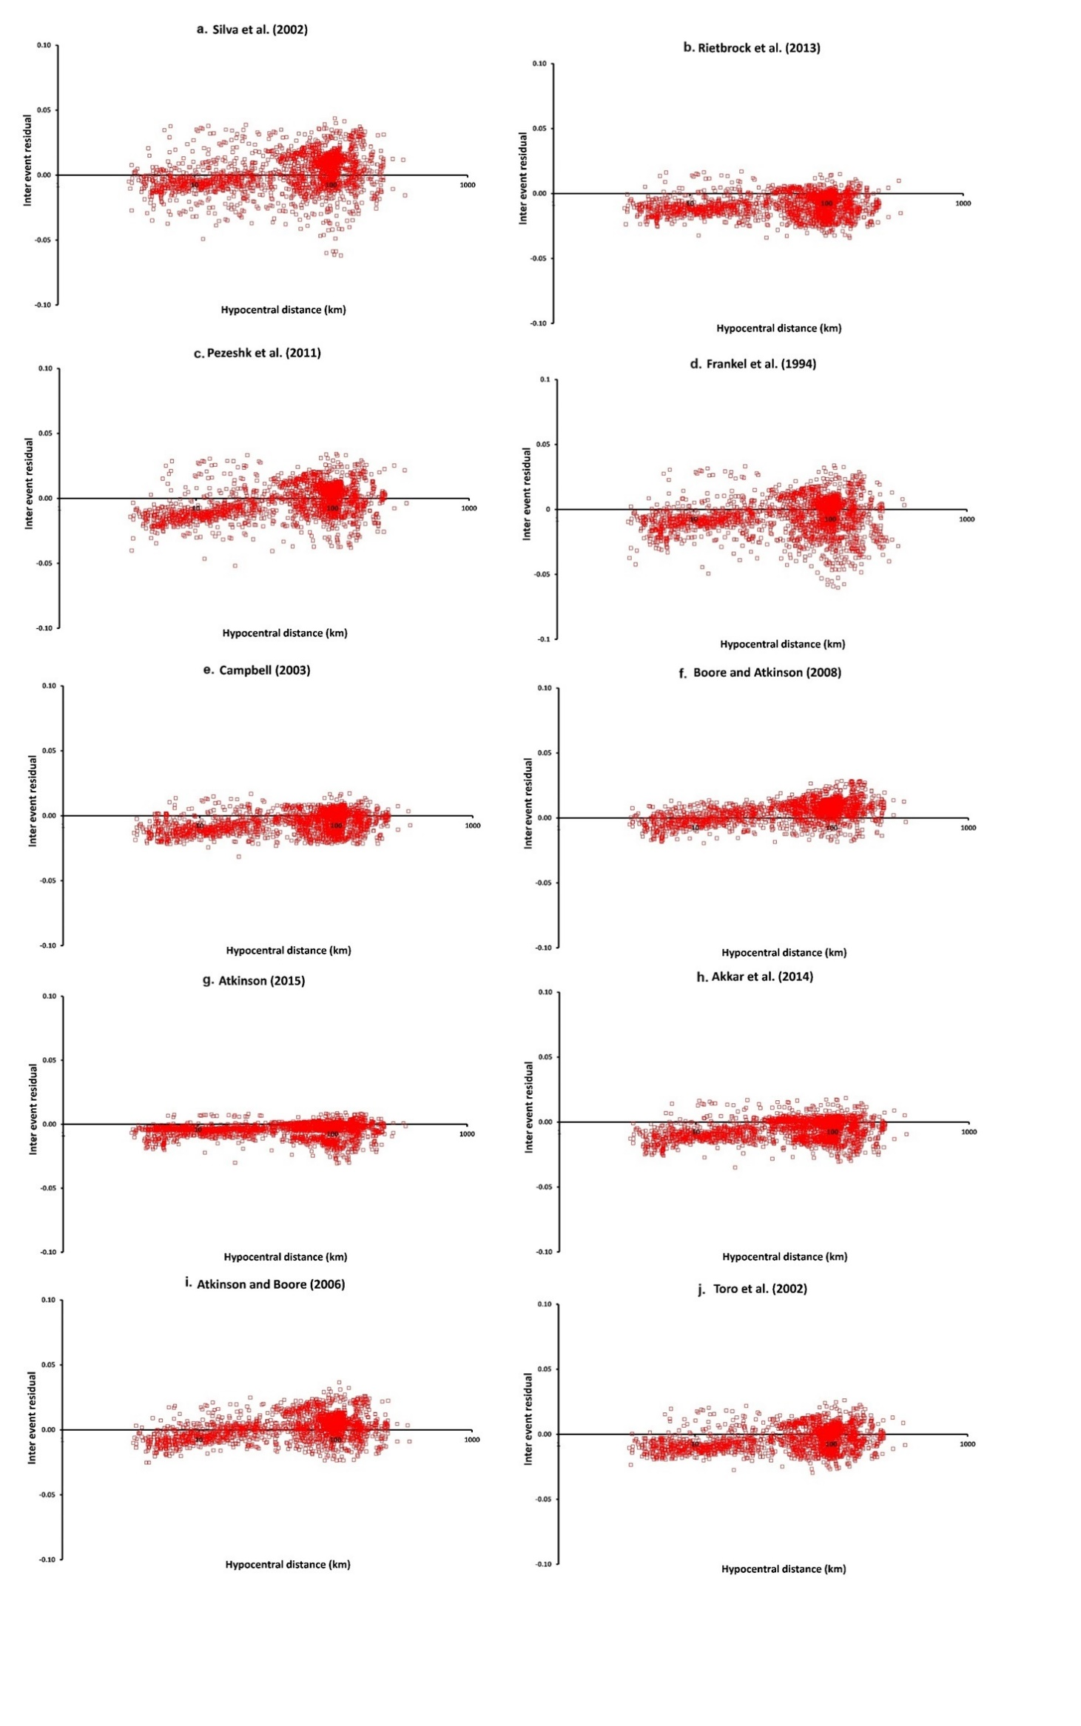
Figure 3: The inter-event residuals of all GMPEs for PGA (T = 0.01s) spectral acceleration versus hypocentral distance.
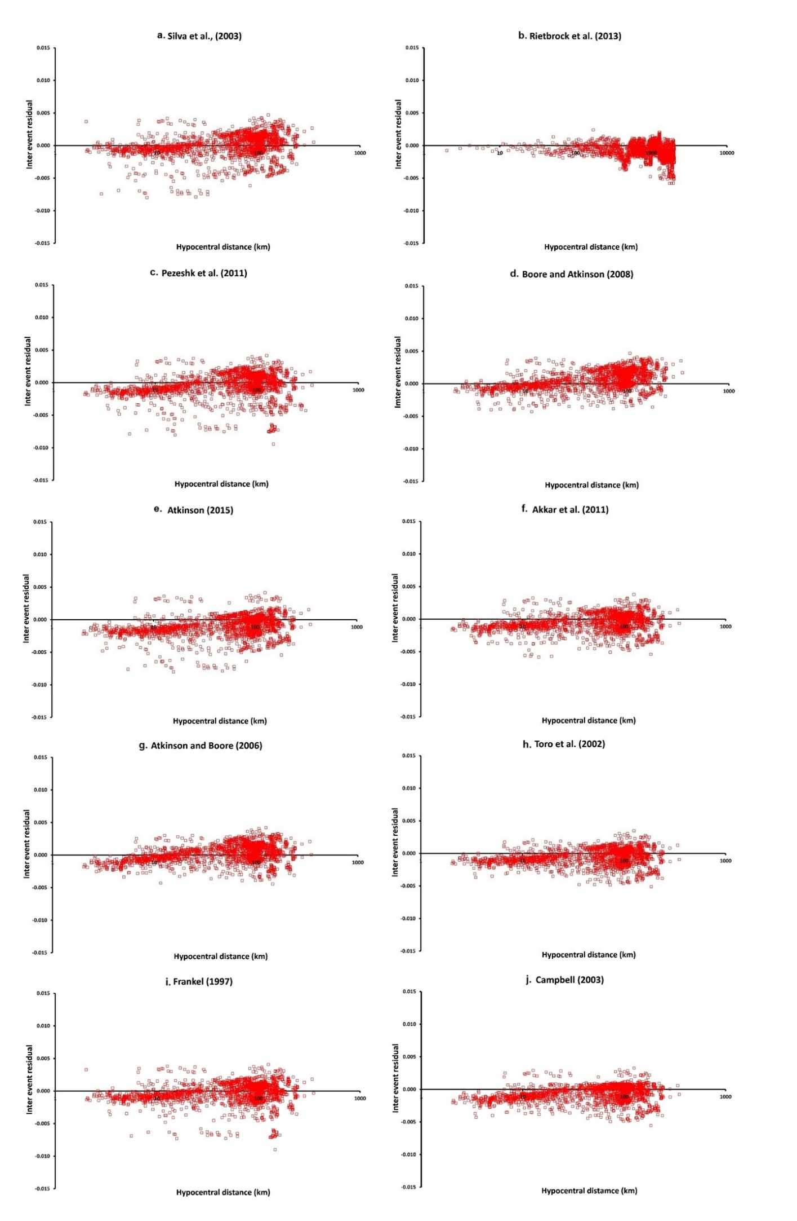
Figure 4: The inter-event residuals of all GMPEs for PSA (T = 0.15s) versus hypocentral distance.

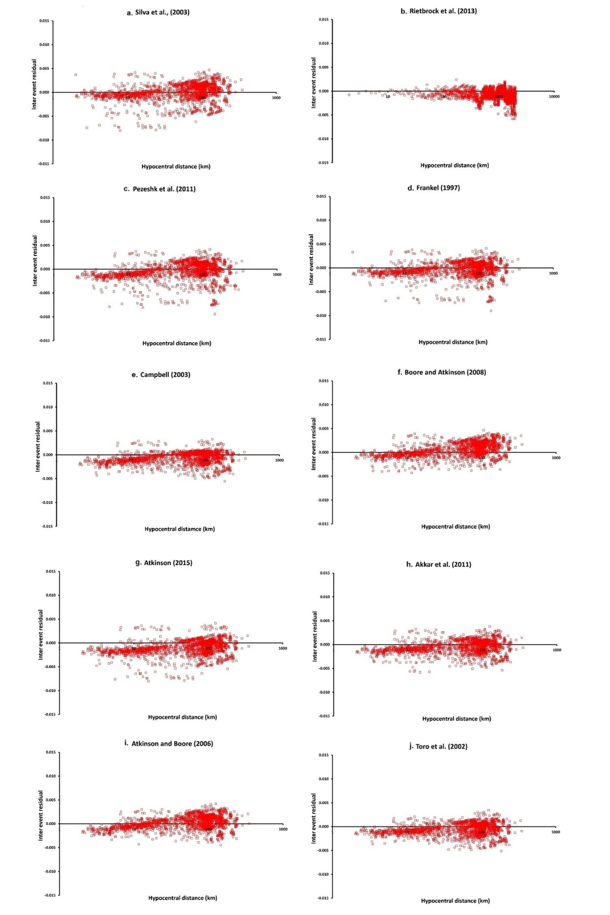
Figure 5: The inter-event residuals of all GMPEs for PGA (T = 2.0s) versus hypocentral distance.

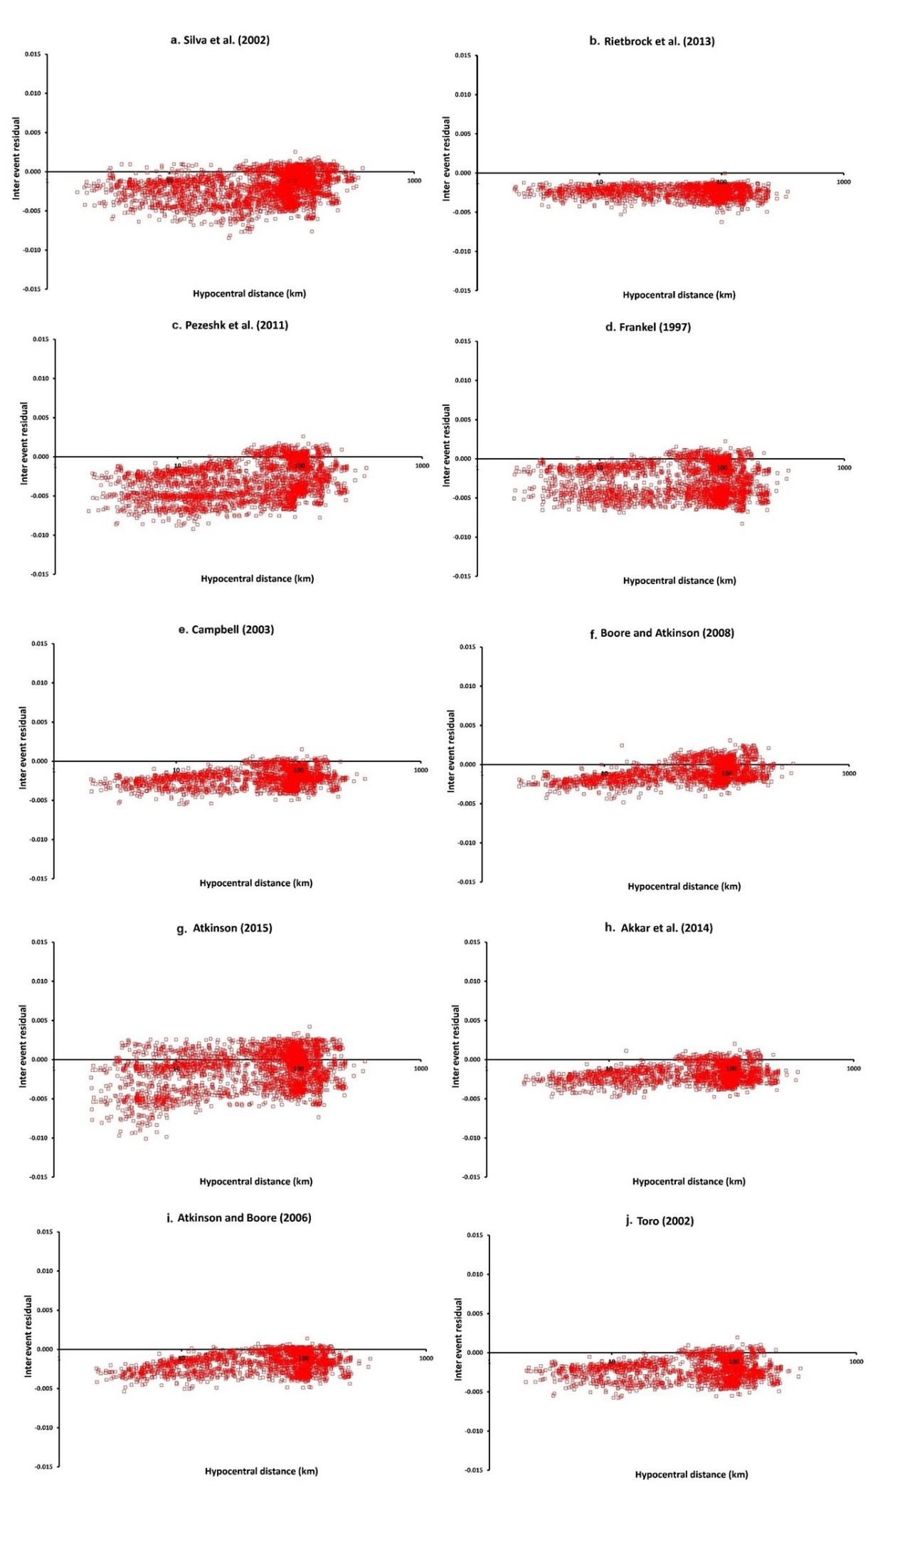
Figure 6: Inter-event terms, also referred to as the mean residual, for the 10 GMPEs for PGA.

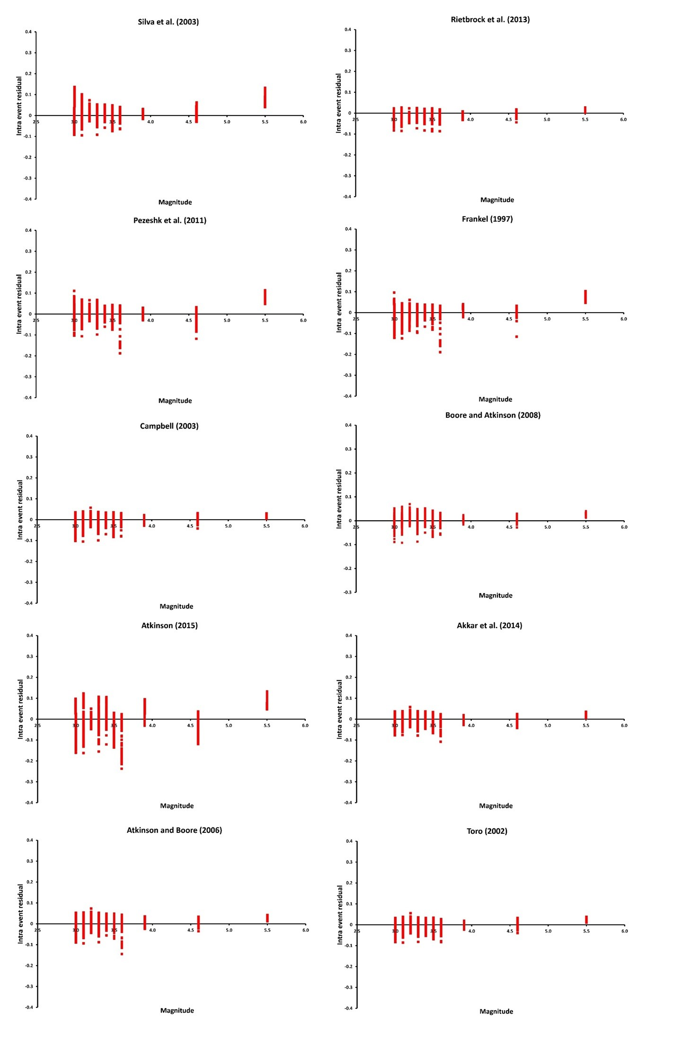
Figure 7: Inter-event terms, also referred to as the mean residual, for the 10 GMPEs T=0.15s spectral period.
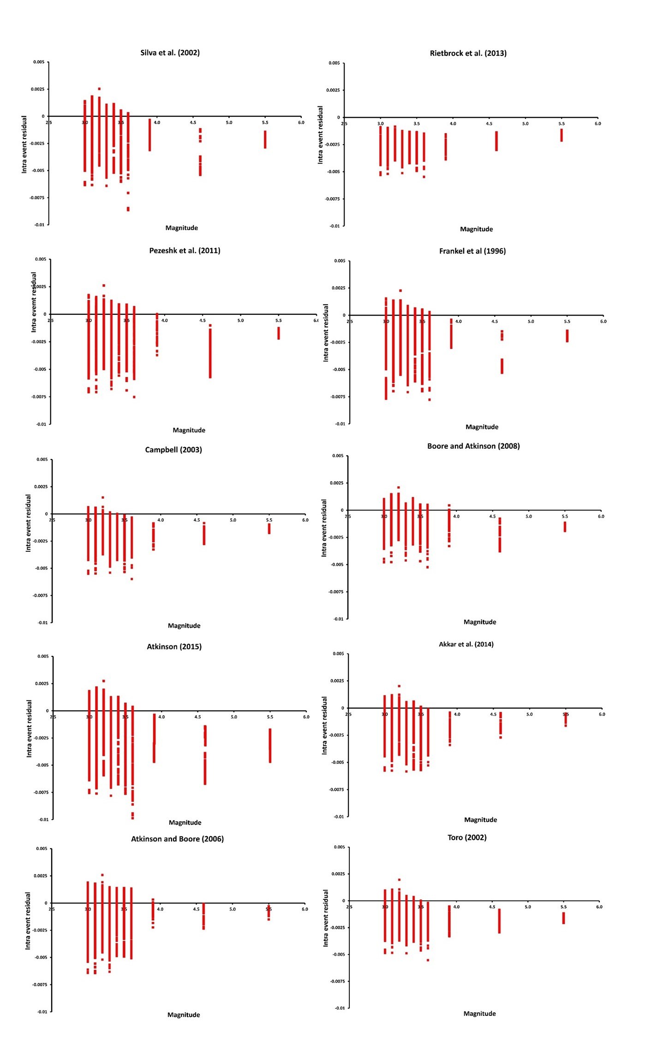
Figure 8: Inter-event terms, also referred to as the mean residual, for the 10 GMPEs for T= 2.0s spectral period.

Negative residuals are obtained where the GMPEs overestimate the ground motion and underestimate where they are positive. In general, all the GMPEs overestimate the ground motion parameters. Using these GMPEs will result in hazard values that are slightly higher than observed values. Much of the observed scatter is at lower magnitudes and larger distances, meaning small events recorded at longer hypocentral distances resulted in large errors. Mining-related seismicity attenuates fast, and with increasing hypocentral distance can also contributed. The selected GMPEs cover a large spectrum and will represent the uncertainty in GMPEs for our region.
Large variations of the residuals are observed for the Atkinson and Boore (2006) model, which appears to underestimate ground motion at short periods but overestimates at long periods at all distances. Considering the trends observed by Campbell (2003), Toro et al. (2002), Boore and Atkinson (2008), Akkar et al. (2014), Rietbrock et al. (2013), and Atkinson and Boore (2006) models consistently appear to match observed data better than the other GMPEs. Akkar et al. (2014) over predicts for all spectral periods. Pezeshk et al., (2011) tend to over predicts for short periods and under predicts for longer periods. Variations in residuals might be because the GMPEs were used outside their derived magnitude range since most of the events used in this study fall outside the applicability range of most GMPEs. Only the Atkinson (2015) model for induced seismicity was derived for short distances (less than 40 km) and can only be used for induced seismic sources.

Comparison of the Orkney earthquake strong-motion data with pre-selected GMPEs
The strike-slip M_{W} 5.5 Orkney earthquake of 5 August 2014, which occurred in the North West Province, South Africa, at about 10:22 GMT, was recorded by the SANSN and the cluster network in the mining regions. The earthquake that falls within the range of magnitude values used in deriving most of the pre-selected GMPEs. Thus, we separately compared its observed ground motion parameters, as recorded by the cluster network of stations, to the predicted values. In Figure 9 we compare the predictions of the ten GMPEs pre-selected in this study to the observations. Rietbrock et al. (2013) and Akkar et al. (2014) predictions fit the data on all the spectral periods analysed, while Atkinson (2015) over predicts all the spectral periods. Due to its short distance of applicability, the Atkinson (2015) model was not used for further analysis. Toro et al. (2002) and Campbell (2003) mainly overestimate most spectral periods whilst fitting well on others. Silva et al. (2002) and Pezeshk et al. (2011) mainly underestimate ground motion although they sometimes overestimate it. Atkinson and Boore (2006) sometimes overestimates (lower spectral periods <0.1 sec) and sometimes fits the observations well (high spectral periods > 0.1 sec). Boore and Atkinson (2008) fit well up to spectral periods of 0.5 seconds, then it overestimates. For PGA, most of the GMPEs overestimate the observed ground motion except for Rietbrock et al. (2013) and Akkar et al. (2014), fit well with the data, while Pezeshk et al. (2011) predict lower values. For 0.05 seconds, Rietbrock et al. (2013), Akkar et al. (2013), Boore and Atkinson (2008) fit the data while the rest of the GMPEs over predict.
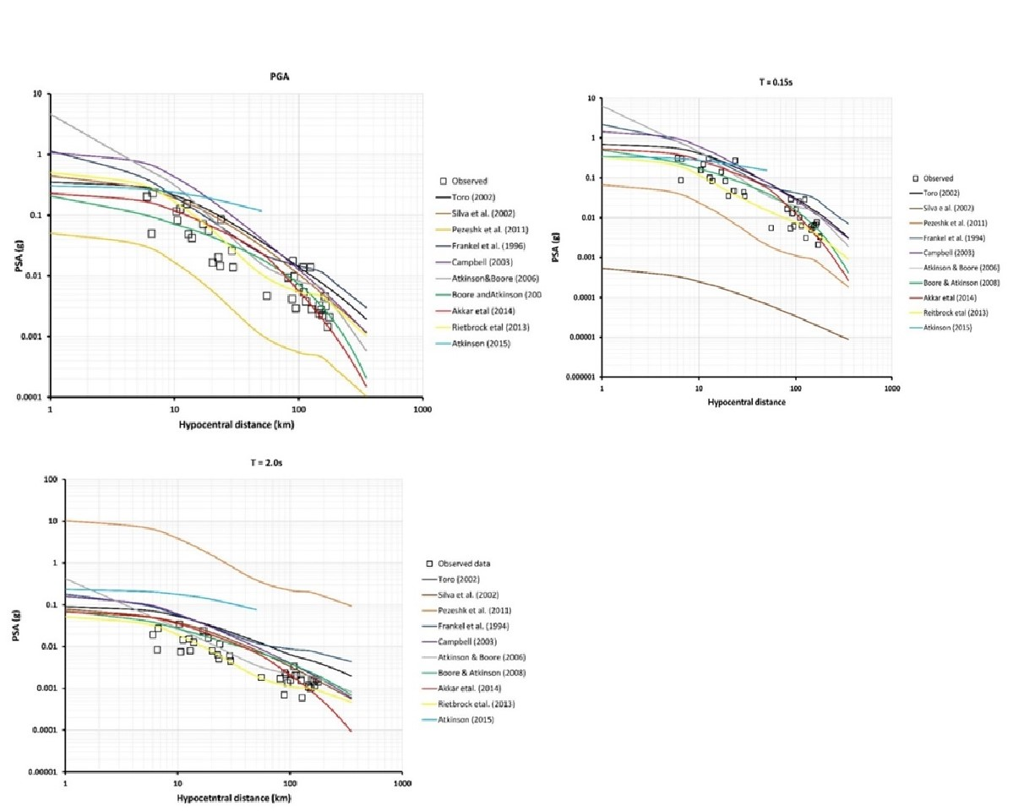
Figure 9: Comparison between the spectral accelerations at three spectral periods recorded during the 2014 Orkney earthquake of magnitude Mw = 5.5 and the predictions obtained with ten preselected GMPEs.
It is apparent from these results that the shape of attenuation curves of only one model cannot capture the real behaviour of the data. Therefore, six GMPEs were selected to cover the lower (Toro et al., 2002; Boore and Atkinson, 2008), median (Akkar et al., 2014; Rietbrock et al., 2013) and upper range (Campbell, 2003; Atkinson and Boore, 2006) of the ground motion in order to capture the uncertainty associated with GMPE selection. These six GMPEs were then used for sensitivity analysis.

Uncertainty analysis related to Ground Motion Prediction Equations
The six GMPEs (AB06, BA08, AKETAL14, TO02, RIETAL13, and CAM03) selected by comparing with local data were used in this study to demonstrate the effect of choice of the model on the hazard results. The analyses are conducted for six cases, each corresponding to a different GMPE, to illustrate the effect of the chosen GMPEs.. The sensitivity of the output to variations in the input parameters is quantified using the Coefficient of Variation (COV), where COV is a measure of relative variability and is related to both the standard deviation (σ) and the mean (μ) through the relation by Cramer (2001a; 2001b; 2002).
$COV= \frac{σ}{μ}$ [5]
COV is a standardized, unitless measure that compares variability between dissimilar groups and characteristics. A small COV value indicates that variation in the related parameter does not show large variation in output, while a large COV indicates that the output is susceptible to variations in the parameter under investigation (Gomez and Gomez, 1984; Cramer, 2002; Campbell et al., 2010).
COV results show high values (>0.3) that indicate large variability in the results (Figure 10). Spatial distribution of the COV values are significantly different for the three spectral periods. High COV values were observed in the central areas for PGA, which decreases north and southwards. For PSA=0.15s, high COV values are found in the eastern side around Johannesburg CBD while for PSA=2.0s they are on the west in Soweto. These high COV values for GMPEs show that this is an important parameter whose selection has significant influence on the hazard. Given the uncertainty in the hazard linked to the GMPEs, it is necessary that a range of models that cover the epistemic uncertainty associated with the models be selected.
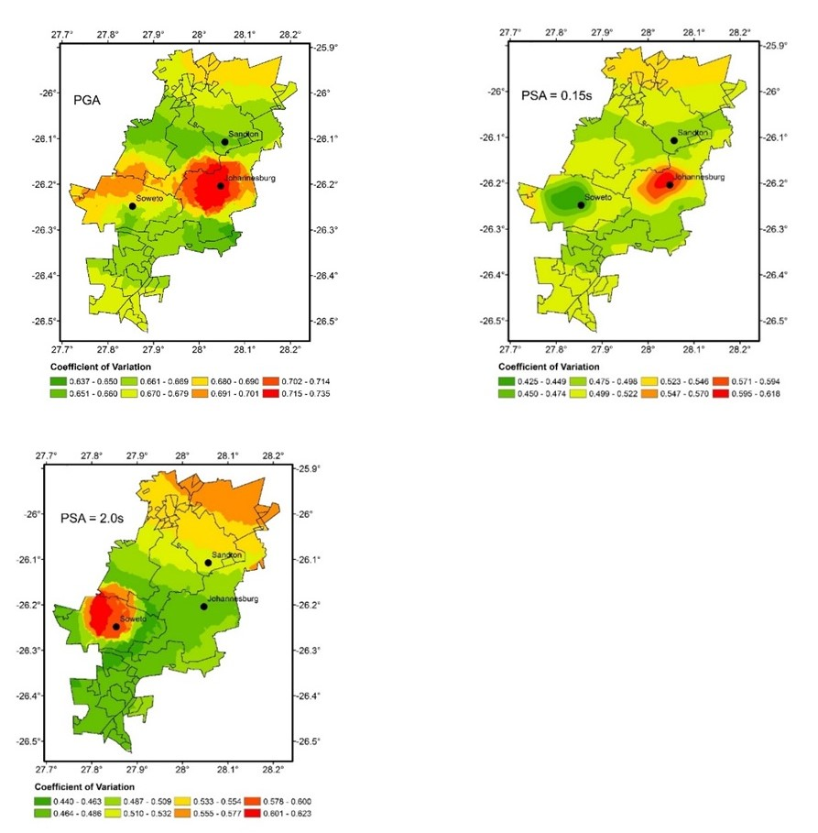
Figure 10: COV results for GMPE seismic hazard sensitivity analysis (a) PGA, (b) PSA = 0.15 s, and (c) PSA = 2.0 s.

Conclusions
Selecting appropriate GMPEs requires a thorough evaluation of local model quality, compatibility with observed data, and consideration of epistemic uncertainties in ground-motion prediction. Given the complexity of the seismotectonic setting in the study area, GMPEs from various tectonic regimes were chosen for the seismic hazard analysis. To minimize uncertainty in the selection process, ten GMPEs were identified and compared with local ground-motion data, from which a set of GMPEs was selected that best fits the data for the region. Six of these GMPEs (Boore and Atkinson, 2008; Campbell, 2003; Akkar et al., 2014; Toro et al., 2002; Rietbrock et al., 2013; and Atkinson and Boore, 2006) were chosen to represent epistemic uncertainty. A sensitivity analysis was conducted to evaluate the impact of GMPE selection on the final hazard estimate. GMPEs based on induced seismicity were excluded, as they did not meet the selection criteria outlined by Bommer et al. (2010), being limited to PGA predictions and not considering other spectral periods. The Atkinson (2015) equation was also excluded because it is applicable only to small magnitudes, whereas seismic hazard analysis focuses on events of moderate to large magnitude that generate ground motions capable of affecting buildings. Comparisons show that when attenuation models are based on a well-assembled database and used within their validity range, they can accurately predict ground motion parameters, especially for short and intermediate structural periods. The methodology adopted in this study aligns with current best practices. Future efforts will be necessary to assess or develop GMPEs for this region as suitable strong-motion data from moderate to large earthquakes are recorded.
Acknowledgements
The authors wish to acknowledge the Council for Geosciences for the time provided to carry out the work
Funding
This work was performed under the PhD funding bursary sponsored by the CGS.
Credit
BM: Conceptualisation, Methodology, Software, Investigation, Validation, Writing, Formal analysis, Visualisation. VM: Conceptualisation, Supervision, Software, Project Management, Writing. RJD: Supervision, Writing

References
Akkar, S., Sandıkkaya, M.A. and Bommer, J.J., (2014). Empirical ground-motion models for point-and extended-source crustal earthquake scenarios in Europe and the Middle East. Bulletin of earthquake engineering, 12(1), pp.359-387.
Atkinson, G.M., (2015). Ground‐motion prediction equation for small‐to‐moderate events at short hypocentral distances, with application to induced‐seismicity hazards. Bulletin of the Seismological Society of America, 105(2A), pp.981-992.
Atkinson, G.M. and D.M., Boore (2006). Earthquake ground-motion prediction equations for eastern North America, Bulletin of the Seismological Society of America, 96(6), 2181–2205, doi: 10.1785/0120050245.
Atkinson, G.M. (2008). Ground-motion prediction equations for eastern North America from a referenced empirical approach: Implications for epistemic uncertainty, Bulletin of the Seismological Society of America, 98(3), pp.1304–1318, doi: 10.1785/0120070199.
Atkinson, G.M. and D.M., Boore (2011). Modifications to existing ground-motion prediction equations in light of new data, Bulletin of the Seismological Society of America, 101(3), 1121-1135, doi: 10.1785/0120100270.
Bommer, J. J., K. J. Coppersmith, R. T. Coppersmith, K. L. Hanson, A. Mangongolo, J. Neveling, E. M. Rathje, A. Rodriguez-Marek, F. Scherbaum, R. Shelembe, P. J. Stafford, and F. O. Strasser 2015. A SSHAC Level 3 Probabilistic Seismic Hazard Analysis for a New-Build Nuclear Site in South Africa, Earthquake Spectra, 31(2), pp.661–698.
Bommer, J.J., S. Akkar & Ö. Kale (2011). A model for vertical-to-horizontal response spectral ratios for Europe and the Middle East. Bulletin of the Seismological Society of America 101(4), pp.1783-1806.
Bommer, J.J., J. Douglas & F.O. Strasser (2003). Style-of-faulting in ground motion prediction equations. Bulletin of Earthquake Engineering 1(2), pp.171-203.
Bommer, J. J., Strasser, F. O., Pagani, M., and Monelli, D., (2013). Quality assurance for logic-tree implementation in probabilistic seismic hazard analysis for nuclear applications: A practical example, Seismological Research Letters, 84, pp.938–945.
Bommer J. J., Scherbaum F., Bungum H., Cotton F., Sabetta F. and Abrahamson N. A., (2005). On the use of logic trees for ground motion prediction equations, Bulletin of the Seismological Society of America, 95, pp. 377-389. doi: 10.1785/0120040073.
Bommer, J.J., Douglas, J., Scherbaum, F., Cotton, F., Bungum, H. and Fäh, D., (2010). On the selection of ground-motion prediction equations for seismic hazard analysis. Seismological Research Letters, 81(5), pp.783-793.
Boore D.M., Stewart J.P., Seyhan E., Atkinson G.M., (2014). NGA‐West2 Equations for Predicting PGA, PGV, and 5% Damped PSA for Shallow Crustal Earthquakes. Earthquake Spectra, 30(3), pp.1057‐1085
Boore, D.M. and Atkinson, G.M., (2008). Ground-motion prediction equations for the average horizontal component of PGA, PGV, and 5%-damped PSA at spectral periods between 0.01 s and 10.0 s. Earthquake Spectra, 24(1), pp.99-138.
Campbell, K.W. (2003). Prediction of strong ground motion using the hybrid empirical method and its use in the development of ground motion (attenuation) relations in eastern North America, Bulletin of the Seismological Society of America, 93, pp.1012–1033.
Cotton, F., G. Pousse, F. Bonilla, and F. Scherbaum (2008). On the discrepancy of recent European ground-motion observations and predictions from empirical models: Analysis of KiK-net accelerometric data and point-sources stochastic simulations, Bull. Seismol. Soc. Am. 98(5) pp.2244–2261.
Cotton, F., Scherbaum, F., Bommer, J.J. and Bungum, H., 2006. Criteria for selecting and adjusting ground-motion models for specific target regions: Application to central Europe and rock sites. Journal of Seismology, 10(2), pp.137.
Douglas, J. 2016. Ground motion prediction equations 1964-2018, http://www.gmpe.org.uk.
Douglas, J., H., Bungum and F., Scherbaum, 2006. Ground-motion prediction equations for southern Spain and southern Norway obtained using the composite model perspective, Journal of Earthquake Engineering, 10(1), pp.33–72.
Douglas, J., (2003). Earthquake ground motion estimation using strong-motion records: a review of equations for the estimation of peak ground acceleration and response spectral ordinates. Earth-Science Reviews, 61(1-2), pp.43-104.
Douglas, J., F., Cotton, N., Abrahamson, S., Akkar, D.M., Boore and C., Di Alessandro, 2011. Pre-selection of ground-motion prediction equations (Task 2), PEER GEM – Global GMPEs Task 2 WG, URL www.nexus.globalquakemodel.org/gem-gmpes/posts/
Douglas, J., B. Edwards, V. Convertito, N. Sharma, A. Tramelli, D. Kraaijpoel, B. Cabrera, N. Maercklin, and C. Troise, 2013. Predicting ground motion from induced earthquakes in geothermal areas, Bulletin of the Seismological Society of America, 103, pp.1875–1897.
Durrheim, R.J., Anderson, R.L., Cichowicz, A., Ebrahim-Trolloped, R., Hubert, G., Kijko, A., McGarr, A., Ortlepp, W.D. and Van der Merwe, N., (2006). The risks to miners, mines, and the public posed by large seismic events in the gold mining districts of South Africa, J Hadjigeorgiou and M Grenon (Editors), In Proceedings of the Third International Seminar on Deep and High Stress Mining, 2-4 October 2006, Quebec City, CANADA, Universite Laval.
Fernandez, L.M. and Van der Heever, P.K., (1985), December. Ground movement and damage accompanying a large seismic event in the Klerksdorp district: Proc 1st International Congress on Rockbursts and Seismicity in Mines, Johannesburg, Sept 1982 pp193–198. Publ Johannesburg: SIAMM, 1984.
Frankel, A., C., Mueller, T., Barnhard, D., Perkins, E.V., Leyendecker, N., Dickman, S., Hanson and M., Hopper, (2004). National Seismic-Hazard Maps: Documentation June 1996, Open-File Report 96-532, U.S. Department of the Interior, U.S. Geological Survey.
Graves, R., B., Aagaard, K., Hudnut, L., Star, J., Stewart and T., Jordan, (2008). Broadband simulation for Mw 7.8 southern San Andreas earthquakes: ground motion sensitivity to rupture speed, Geophysical Research Letters, 35, L22302, doi:10.1029/2008GL035750.
Grobbelaar, M.R.G., Birch, D. and Cichowicz, A., (2017). Comparison of data from complementary seismograph networks in a mining district. In Proceedings of the Eighth International Conference on Deep and High Stress Mining ,pp. 117-124. Australian Centre for Geomechanics.
Gupta, I.D., 2006, December. Defining source-to-site distances for evaluation of design earthquake ground motion. In Proceedings of the 13th Symposium on Earthquake Engineering, Roorkee, 1, pp. 295-306.
Hartnady C.J.H. (2002). Earthquake hazard in Africa: perspectives on the Nubia–Somalia boundary, South African Journal of Science 98, pp.425-428,
Johnston, A.C., 1994. The stable continental region earthquake database. The Earthquakes of Stable Continental Regions: Assessment ox Large Earthquake Potential, EPRI Rpt. TR, 102261, pp.3-1.
Manzunzu, B., Midzi, V., Mulabisana, T.F., Zulu, B., Pule, T., Myendeki, S. and Rathod, G.W.,( 2019). Seismotectonics of South Africa. Journal of African Earth Sciences, 149, pp.271-279.
Manzunzu, B., Midzi, V., Mangongolo, A. and Essrich, F., 2017. The aftershock sequence of the 5 August 2014 Orkney earthquake (M L 5.5), South Africa. Journal of Seismology, 21(6), pp.1323-1334.
Midzi, V., Manzunzu, B., Mulabisana, T., Zulu, B.S., Pule, T. and Myendeki, S., 2020. Probabilistic seismic hazard maps for South Africa. Journal of African Earth Sciences, 162, pp.103689. https://doi.org/10.1016/j.jafrearsci.2019.103689
Musson, R.M.W. and Sargeant, S.L., (2007). Eurocode 8 seismic hazard zoning maps for the UK. British Geological Survey Technical Report, CR/07/125, pp. 70 .
Malservisi, R., Hugentobler, U., Wonnacott, R. and Hackl, M., (2003). How rigid is a rigid plate? Geodetic constraint from the TrigNet CGPS network, South Africa. Geophysical Journal International. 192(3), 918–28.
McGarr, A. and Fletcher, J. B. (2005). Development of ground–motion prediction equations relevant to shallow mining–induced seismicity in the Trail Mountain area, Emery County, Utah, Bulletin of the Seismological Society of America, 95, pp.31-47.
Pezeshk, S., Zandieh, A. and B., Tavakoli (2011). Hybrid Empirical Ground-Motion Prediction Equations for Eastern North America Using NGA Models and Updated Seismological Parameters, Bulletin of the Seismological Society of America, 101(4), pp.1859-1870.
Rietbrock, A., Strasser, F. and Edwards, B. (2013). A stochastic earthquake ground-motion prediction model for the United Kingdom, Bulletin of the Seismological Society of America, 103, pp.57-77.
Scherbaum, F., Delavaud, E. and Riggelsen, C. (2009). Model selection in seismic hazard analysis: an information-theory perspective, Bulletin of the Seismological Society of America, 99, pp.3234-3247.
Scherbaum, F., Schmedes, J. and Cotton, F., (2004). On the conversion of source-to-site distance measures for extended earthquake source models. Bulletin of the Seismological Society of America, 94(3), pp.1053-1069.
Shoja-Taheri, J., S., Naserieh and G., Hadi (2010). A test of the applicability of NGA models to the strong ground-motion data in the Iranian plateau, Journal of Earthquake Engineering, 14, pp.278 – 292.
Silva, W., N., Gregor and R., Darragh (2002). Development of regional hard rock attenuation relations for central and eastern North America, Technical Report, Pacific Engineering and Analysis.
Stamps, D.S., Saria, E. and Kreemer, C., 2018. A geodetic strain rate model for the East African Rift system. Scientific reports, 8(1), pp.1-8.
Skarlatoudis, A.A., 2017. Applicability of ground-motion prediction equations to a Greek within-slab earthquake dataset. Bulletin of Earthquake Engineering, 15, pp.3987-4008.
Stewart, J.P., Douglas, J., Javanbarg, M., Bozorgnia, Y., Abrahamson, N.A., Boore, D.M., Campbell, K.W., Delavaud, E., Erdik, M. and Stafford, P.J., (2015). Selection of ground motion prediction equations for the Global Earthquake Model. Earthquake Spectra, 31(1), pp.19-45.
Toro, G.R., N.A., Abrahamson and J.F., Schneider (1997). Model of strong ground motions from earthquake in central and eastern North America: Best estimates and uncertainties, Seismological Research Letters, 68(1), pp. 41–57.
Toro, G.R. (2002). Modification of the Toro et al. (1997) attenuation equations for large magnitudes and short distances, Technical Report, Risk Engineering.
Zulu 2018. Time-dependent seismic hazard assessment in the mining regions of the Gauteng province, South Africa, unpublished MSc thesis. University of Witwatersrand.

